Explain the difference in CPU and GPU architecture?
Architecturally, the CPU is composed of just a few cores with lots of cache memory that can handle a few software threads at a time. In contrast, a GPU is composed of hundreds of cores that can handle thousands of threads simultaneously. GPUs deliver the once-esoteric technology of parallel computing. CPU IS sequential task. GPU is for parallel task.

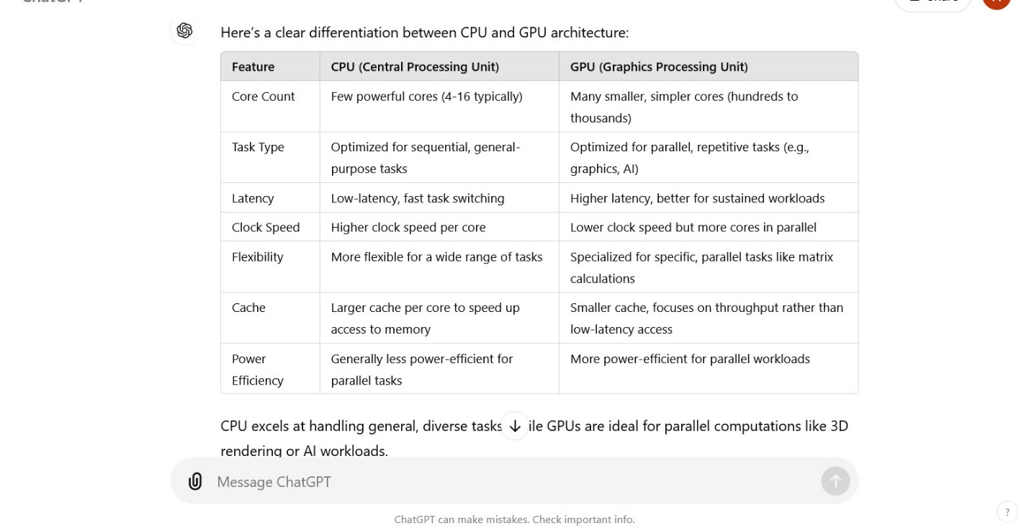

• cache is necessary because it is much faster than RAM.
• CPU caches provide high-speed access to frequently used data, significantly reducing latency and preventing the CPU from being idle while waiting for slower memory.
• Even with large amounts of RAM, without cache, modern CPUs would be underutilized and overall performance would be much lower.

The CPU uses a memory hierarchy to manage data efficiently:
- Registers (fastest but smallest) store immediate data for operations.
- L1 Cache (small, very fast) stores data that the CPU needs imminently.
- L2 Cache (larger, fast) stores data that is used less frequently than L1 data.
- L3 Cache (largest, slower) stores data shared across cores and used less frequently than L2.
- RAM (large, slower than cache) stores data not immediately needed by the CPU but still faster than storage (HDD/SSD).
- Registers are located directly inside the CPU itself. This means the data in registers is immediately available to the CPU without having to travel through buses or other connections.
- Cache (which is slower than registers) is also close to the CPU but still needs to be accessed through a small bus, whereas registers are part of the CPU circuitry, making access almost instantaneous.
Reason for speed: Being directly part of the CPU architecture allows the CPU to access registers without any delay caused by transferring data across buses or through intermediate layers.
What is cache memory ?
Cache memory is a type of temporary memory that stores frequently accessed data for faster access by the central processing unit (CPU). It's a vital component of computer systems that helps improve performance.
Cache memory acts as a buffer between the CPU and the main memory to ensure faster data access, improving overall system performance.
Cache memory is much faster than RAM but smaller in size. It can be accessed very quickly, often in just a few CPU cycles, because it uses faster types of memory like SRAM (Static Random Access Memory).

• L1 Cache (Level 1):
- This is the fastest and smallest cache, located directly within the CPU core. Each CPU core has its own dedicated L1 cache.
- It is divided into two parts: Instruction Cache (stores the instructions the CPU needs) and Data Cache (stores the data that the CPU operates on).
• L2 Cache (Level 2):
- L2 cache is larger than L1 but slightly slower. It's still very close to the CPU and can be dedicated to each CPU core or shared among cores, depending on the processor architecture.
• L3 Cache (Level 3):
- L3 cache is the largest and slowest among the CPU caches, often shared by all cores in a multi-core processor. It acts as a larger buffer before the CPU has to access the slower RAM.
Greed and Cookie Problem Summary
- L1 Cache (Level 1) 🚀
  - Located inside the CPU core for fastest access.
  - Divided into Instruction Cache (for CPU instructions) and Data Cache (for CPU data operations).
- L2 Cache (Level 2) 🛠️
  - Larger than L1, slightly slower.
  - Close to CPU cores; can be shared or dedicated per core based on architecture.
- L3 Cache (Level 3) 📦
  - Largest and slowest CPU cache.
  - Shared among all cores in multi-core processors, acts as a buffer before accessing RAM.
Interview Questions:
- What is the purpose of L1, L2, and L3 caches in a CPU?
  - Answer: "L1 cache provides the fastest access to instructions and data within the CPU core, optimizing performance. L2 cache, larger but slightly slower, enhances access speed for each core or shares across cores. L3 cache acts as a buffer, optimizing overall memory access efficiency in multi-core processors."
- How does cache size affect CPU performance?
  - Answer: "A larger cache size generally improves CPU performance by reducing the time CPUs spend waiting for data from main memory. L1 cache, being the smallest but fastest, ensures critical instructions and data are readily available."
- Why is L3 cache shared among CPU cores in multi-core processors?
  - Answer: "Sharing L3 cache across cores optimizes memory usage and reduces latency in accessing shared data between cores, enhancing overall processor efficiency."
These explanations and questions provide a detailed understanding of CPU cache levels and their real-world applications in optimizing processor performance.
Why Use Cache if RAM Exists?
- Speed: Cache provides much faster access to data than RAM, so it helps bridge the speed gap between the CPU and RAM.
- Efficiency: By keeping frequently used data close to the CPU, cache minimizes delays, allowing the CPU to process data more efficiently without constantly waiting for RAM access.
What happens if don’t cache?
Without cache, the CPU would have to fetch data from RAM constantly, slowing down the entire system. Without registers, the CPU wouldn't be able to perform computations efficiently.
Both are essential: Registers handle immediate computation, while cache ensures the CPU has fast access to a broader range of frequently used data.

- 📚 Concept Explanation:
  - Cache is crucial for storing recently accessed data and instructions, acting as a mediator between fast CPU and slower RAM.
  - Registers handle immediate computations, while cache ensures quick access to frequently used data across a broader range.
- 🌍 Real-World Application:
  - Example: In web browsing, cache stores frequently visited web pages locally, reducing load times during subsequent visits.
  - Application: In gaming consoles, cache enhances gameplay by storing frequently used textures and game data for faster access.
- 💬 Interview Questions:
  - Question: How does cache improve CPU performance in real-world applications?
    - Answer: Cache reduces latency by storing frequently accessed data closer to the CPU, speeding up computations in applications like databases and web servers.
  - Question: Can you explain a scenario where cache utilization significantly impacts system performance?
    - Answer: In financial trading systems, cache speeds up access to market data, enabling faster decision-making and trade execution.
These points provide a detailed understanding of cache usage, its practical applications, and relevant interview questions with answers focused on real-world scenarios.

What is registers?
Registers are the fastest and used by the CPU to hold data and instructions actively being processed. It handles immediate computation.
• Registers:
- Inside the CPU core itself.
- Data in registers can be accessed in one CPU clock cycle or even less.
• Cache:
- Located very close to the CPU, either within the CPU die or on the chip, but not directly inside the core.
- Cache access times are fast but usually take a few more clock cycles than registers, especially as you move from L1 to L3 cache.
What are L1, L2, L3 caches?
- L1 cache
The fastest and smallest cache, located directly in the CPU. It's also known as the primary cache. L1 cache is typically divided into two parts: L1i, which stores instructions, and L1d, which stores data.
- L2 cache
Often larger than L1, but slower. It can be located on the processor chip or on a separate chip connected to the CPU by a high-speed bus.
- L3 cache
The largest cache, but also the slowest. It's located on the computer that uses the L2 cache. L3 cache is designed to improve the performance of L1 and L2

CPU (Central Processing Unit):
- The CPU is the main component of a computer responsible for executing instructions from programs.
- It performs the basic arithmetic, logic, control, and input/output (I/O) operations.
- The CPU is often referred to as the "brain" of the computer.
- A CPU typically contains cores (which are the individual processing units), registers, ALU (Arithmetic Logic Unit), control unit, and cache.

The Role of a CPU
The CPU is responsible for carrying out these instructions and processing data in order to complete tasks assigned by programs or applications. To do this, it needs to fetch data from memory and decode it before executing any commands it receives from software.
This process occurs very quickly; CPUs can execute millions of instructions per second! Additionally, CPUs are designed with multiple cores so they can process multiple tasks simultaneously.
How central processing unit works?
A CPU works through two main stages: Fetch-Execute Cycle and Decode-Execute Cycle.
In the Fetch-Execute cycle, the processor fetches an instruction from memory, then decodes and executes that instruction before moving on to the next one until all instructions are complete.
In the Decode-Execute cycle, the processor first decodes an instruction before executing it; this means that each instruction must be decoded once before being executed multiple times if necessary.
Cpu: What is a CPU | Lenovo INSummary
- 🖥️ CPU Working Principle
  - The CPU operates via two main cycles: Fetch-Execute Cycle and Decode-Execute Cycle.
  - Fetch-Execute Cycle: Retrieves instructions from memory, executes them sequentially.
  - Decode-Execute Cycle: Decodes instructions before executing, ensuring efficient processing.
- 🌍 Real-World Application
  - Example: In a web server, CPU executes instructions to handle incoming requests.
  - Application: Ensures timely processing of tasks like data retrieval and response generation.
- 🎙️ Interview Questions
  - How does a CPU process instructions from memory?
    - Answer: CPUs fetch instructions, decode them, and execute them in sequence.
  - Can you explain the importance of the Fetch-Execute cycle in real-world scenarios?
    - Answer: It ensures efficient utilization of CPU resources by executing tasks in a structured manner.
- Why does CPU performance matter?
- The performance of your CPU has a direct impact on overall system performance. A high-performance processor allows for faster application launch times, smoother multitasking between programs, and better video gaming experiences.
- Additionally, having a powerful processor helps to ensure that your computer can keep up with the latest software updates. As software becomes more advanced, it requires more power from your processor to run properly; if your processor is not powerful enough, it may be unable to keep up with these updates and cause your system to slow down or freeze up.
- How can I optimize my processor's performance?
- There are several ways to optimize your processor’s performance. One way is to make sure that you are running the latest version of Windows or whatever operating system you use on your computer; this will help ensure that there are no compatibility issues between the OS and your hardware components.
- Furthermore, you should regularly check for driver updates for your hardware devices and install them if necessary; outdated drivers can cause decreased performance due to incompatibilities with newer versions of software or hardware components.
- Finally, make sure that your PC isn’t running too many background processes – these can take up valuable processing power and slow down overall system performance significantly.
- CPUs play an integral role in modern computing by performing calculations quickly and accurately so that people can use computers effectively in their everyday lives.
- Whether you’re gaming or working on a project, your computer’s CPU is essential for carrying out operations efficiently and reliably – so be sure to give it some extra love! Understanding how CPUs work can help you make better decisions when purchasing new hardware upgrades or choosing the right software applications for your system.
- Scope:
  - CPU specifically refers to the central processing unit that handles general-purpose tasks in a computer.
  - Processor is a more general term that can refer to any processing unit, including CPUs, GPUs, and other specialized processors.
- Usage:
  - In everyday conversation, people often use "processor" to mean "CPU," but technically, a processor could refer to other components that perform specific types of processing.
Example:
- If you say "My processor is an Intel Core i7", you are talking about the CPU.
- If you say "My computer has multiple processors", you could mean that it has a CPU, GPU, and possibly other specialized processing units.
Conclusion:
- CPU is a specific type of processor designed to handle general computing tasks.
- Processor is a broader term that can refer to any unit that processes data, including the CPU and other specialized chips (e.g., GPU, DSP).
- • CPU is a specific type of processor that does most of the general tasks.
- • Processor is a general term that can refer to the CPU or any other chip that processes information (like the GPU or DSP).
The process of how the CPU fetches data from memory involves several steps, including accessing data from different types of memory (like cache, RAM, and secondary storage). Here's a detailed breakdown of how this process works:
1. Instruction Fetching
- Program Counter (PC): The CPU uses a component called the Program Counter to keep track of the address of the next instruction to be executed. The PC points to the location in memory where the instruction is stored.
- Fetch Cycle: When the CPU needs to execute an instruction, it fetches it from memory:
  - The CPU sends a request to the memory controller for the instruction at the address indicated by the PC.
  - The instruction is retrieved and loaded into the CPU's instruction register.
2. Decoding the Instruction
- After fetching, the CPU decodes the instruction to determine what operation needs to be performed and which data it needs to operate on.
3. Data Fetching
- If the instruction involves data (like arithmetic operations), the CPU needs to fetch the required data from memory.
- The data fetching process typically follows these steps:
  - Check Cache Memory:
    - The CPU first checks the L1 cache (the smallest and fastest cache). If the required data is there (cache hit), it’s used directly.
    - If the data is not in L1 (cache miss), the CPU checks L2 and then L3 caches, in that order.
  - Accessing RAM:
    - If the data is not found in the caches, the CPU requests it from main memory (RAM).
    - The memory controller locates the data in RAM and sends it back to the CPU.
  - Storing in Registers:
    - Once fetched, the data is typically loaded into CPU registers, which are used for operations.
4. Execution
- After fetching the instruction and any required data, the CPU executes the instruction using the fetched data.
5. Write Back (if necessary)
- If the instruction modifies data (like an addition operation), the result may be written back to the appropriate memory location (register, cache, or RAM).
Data Flow Summary:
- Fetch instruction from memory (Program Counter points to instruction address).
- Decode the instruction to determine needed data.
- Check caches (L1, L2, L3) for the required data.
- Access RAM if the data is not found in caches.
- Load data into registers for processing.
- Execute the instruction using the data.
- Write back results if needed.
Key Points:
- Cache Memory: Speeds up the process by holding frequently accessed data closer to the CPU.
- Registers: Provide the fastest access for the data currently in use by the CPU.
- Memory Hierarchy: The system uses a hierarchy of memory types to balance speed and capacity, ensuring efficient data fetching.
• Volatility:
- RAM: Volatile (loses data when powered off).
- Secondary Memory: Non-volatile (retains data).
• Speed:
- RAM: Fast access speeds, suitable for active processes.
- Secondary Memory: Slower access speeds, used for long-term storage.
• Structure:
- RAM: Organized in addressable memory cells.
- Secondary Memory: Organized in files, sectors, and blocks.
Secondary memory is slower than RAM. HDDs have mechanical parts that introduce latency, while SSDs are faster due to the lack of moving parts but are still slower than RAM.
• HDDs rely on mechanical components, which introduce delays in data access and transfer speeds.
• SSDs, being entirely electronic, provide faster data access, lower latency, and higher data transfer rates due to their lack of moving parts and efficient architecture.

• HDD:
- Limited by RPM: The speed at which the platters spin (measured in RPM, or revolutions per minute) limits data transfer rates. Common HDD speeds are 5400 RPM and 7200 RPM, which determine how quickly data can be read from or written to the disk.
• SSD:
- Higher Transfer Rates: SSDs have significantly higher data transfer rates, often exceeding 500 MB/s for SATA SSDs and up to several GB/s for NVMe SSDs, allowing for faster data retrieval and storage.
How does information travel from Secondary Memory to CPU Registers.?
the CPU sends a request to the memory controller or the operating system to fetch that data.
The memory controller identifies the location of the requested data on the secondary storage.
The controller reads the data from the secondary memory.
• The data read from secondary memory is temporarily stored in a buffer (a small area of memory) or directly transferred to main memory (RAM).
• Main Memory Loading: If the data is buffered, it is then transferred to the main memory, which is much faster and serves as a working area for active data.

- The CPU generates a memory address for the required data stored in RAM.
- Address Bus: The address bus carries this address to the RAM, specifying where the data is stored.
- Data Bus: The RAM sends the requested data back to the CPU over the data bus.
5. Loading Data into CPU Registers:
- CPU Control Unit: The control unit of the CPU coordinates the transfer of data from RAM to CPU registers.
- Registers: The data is loaded into specific CPU registers, which are small, fast storage locations within the CPU used for quick data manipulation and arithmetic operations.
6. Data Manipulation:
- Once the data is in the registers, the CPU can perform operations such as arithmetic calculations, logical operations, or data transformations quickly.
Secondary Memory (HDD/SSD)
↓
Memory Controller
↓
Main Memory (RAM)
↓
CPU Control Unit
↓
CPU Registers

What is spin lock?
It is a synchronouncs mechanism . It used for short critical section.thread will repeatedly will check for lock variable to acquire it without allowing thread to sleep.
What is lock state?
How does a computer works?
When you turn on your computer the computer loads data from rom and performs the power on self-test to make sure all the components are functioning properly, the memory controller checks all of this memory addressing with quick read write operation to ensure they are no errors in the memory chips.

Explain how computer memory works.
How Memory Works
- Data Storage:
  - Data is stored in binary (0s and 1s) across memory cells.
  - Each memory cell has an address for easy retrieval.
- Data Access:
  - The CPU communicates with memory via a bus system.
  - It sends read/write requests to the memory controller, which manages data flow.
- Data Transfer:
  - Data is transferred from secondary storage to RAM when needed.
  - The CPU processes data in RAM and may use cache memory for quick access to frequently used information.
- Memory Management:
  - Operating System (OS):
    - Manages memory allocation for applications, ensuring efficient use.
    - Implements virtual memory, allowing the system to use disk space as additional RAM.
- Virtual Memory:
  - Combines physical RAM with disk space to create the illusion of more memory.
  - Allows larger applications to run on systems with limited RAM.
Example Scenario
- When you open an application:
  - The OS loads the application data from the hard drive to RAM.
  - The CPU retrieves instructions and data from RAM or cache as needed.
  - Any changes or new data created by the application can be saved back to secondary storage.

Random access memory (RAM) is the best-known form of computer memory. This is what allows your computer to surf the internet and then quickly switch to loading an application or editing a document. RAM is considered "random access" because you can access any memory cell directly if you know the row and column that intersect at that cell.

Summary of differences: SSD vs. HDD
 | SSD | HDD
Stands for | SSD stands for Solid State Drive. | HDD stands for Hard Disk Drive.
How it works | SSDs store data on electronic circuits. | HDDs store data on mechanically moving, magnetic platters.
Read process | An SSD controller finds the correct address and reads its charges. | Ann HDD I/O controller sends a signal that moves the actuator arm. The read/write head then reads charges.
Write process | An SSD copies data to a new block, then erases the old block. It then writes new to the old block by changing its charges. | An HDD moves the read/write head to the nearest available location. It then writes data by changing the charge of bits in that area.
Performance | SSDs are faster. They’re silent and run cooler. | HDDs are slower as their platters have to move around. They release more heat and are noisy.
Cost | SSDs are costlier. | HDDs are less costly and larger storage volumes are commercially popular.
Durability | SSDs are electrical, which makes them less prone to damage. | HDDs have moving mechanical parts that make them comparatively less durable.
How can AWS support your HDD and SSD requirements?
Amazon Web Services (AWS) has several storage solutions to offer that abstract solid state drive (SSD) and hard disk drive (HDD) concerns:
- Amazon Elastic Block Store (Amazon EBS) offers low-cost cold HDD storage in the cloud.
- Amazon Elastic File System (Amazon EFS) is a serverless, set-and-forget file system for AWS compute services. This allows you to access files and scale or shrink storage as you require.
- Amazon Simple Storage Service (Amazon S3) offers data availability, security, performance, and industry-leading scalability for all types of data.
- AWS Storage Gateway provides virtually unlimited cloud storage to on-premises applications.
We also offer Amazon Elastic Compute Cloud (Amazon EC2), which provides a wide selection of instance types optimized for different use cases. Various combinations of CPU, memory, storage, and networking capacity are available, so you can choose the appropriate mix of resources for your application environment in the cloud. Amazon EC2 offers general-purpose and storage-optimized instances with varying SSD and HDD configuration options.
Get started with cloud storage on AWS by creating a free account today.

https://computer.howstuffworks.com/boolean.htm
https://computer.howstuffworks.com/bytes.htm
How Memory Works
- Data Storage:
  - Data is stored in binary (0s and 1s) across memory cells.
  - Each memory cell has an address for easy retrieval.
- Data Access:
  - The CPU communicates with memory via a bus system.
  - It sends read/write requests to the memory controller, which manages data flow.
- Data Transfer:
  - Data is transferred from secondary storage to RAM when needed.
  - The CPU processes data in RAM and may use cache memory for quick access to frequently used information.
- Memory Management:
  - Operating System (OS):
    - Manages memory allocation for applications, ensuring efficient use.
    - Implements virtual memory, allowing the system to use disk space as additional RAM.
- Virtual Memory:
  - Combines physical RAM with disk space to create the illusion of more memory.
  - Allows larger applications to run on systems with limited RAM.
Example Scenario
- When you open an application:
  - The OS loads the application data from the hard drive to RAM.
  - The CPU retrieves instructions and data from RAM or cache as needed.
  - Any changes or new data created by the application can be saved back to secondary storage.
Is flash memory same as RAM?
No, flash memory is not the same as RAM. RAM is volatile and only stores data while the power is on, while flash memory is non-volatile and stores data even when the power is off.
What do you mean flash memory?
Flash memory is also known as flash storage. Flash memory is a type of non-volatile memory that can be erased and reprogrammed.

How does we block any service or app
Open task manager, on startup app , click the app right click disable
In system open run r type msconfig you will go to startup apps
RAM : DATA IS LOST WHEN POWER IS LOST.
How to disable or enable storage device from bios?
When I Restart your computer I will get control bios during boot process press the keys like f2, delete then I go to advanced settings option I will find storage device so there I can find enable or disable option after I save the activities using f10.

what is blod how does it occur in os
2/2
ChatGPT said:
ChatGPT
BLOD (Blue Screen of Death), also known as a Blue Screen Error, is a critical system error that occurs in Windows operating systems. It indicates a fatal system error where the operating system has encountered a problem that it cannot recover from, leading to a crash. Here’s a breakdown of what BLOD is, how it occurs, and its common causes:
What is BLOD?
- Definition:
  - BLOD is a stop error screen displayed by the Windows OS when it encounters a critical failure.
- Characteristics:
  - The screen is usually blue with white text, providing information about the error and suggesting a restart.
  - It may display error codes and messages to help diagnose the issue.
How Does BLOD Occur?
BLOD typically occurs due to various reasons related to hardware, software, or system configuration. Here’s how it happens:
- System Error Detection:
  - The operating system continuously monitors the system for errors. When it detects a serious issue that can compromise the stability of the system, it triggers a BLOD.
- Crash Dump Creation:
  - Before displaying the BLOD, Windows creates a memory dump file containing information about the system state at the time of the error. This dump file can be used for troubleshooting.
- User Notification:
  - The OS displays the blue screen to alert the user about the critical error and prevent further damage. The user must restart the computer to recover from the error.
Common Causes of BLOD
- Hardware Issues:
  - Faulty RAM: Defective memory can lead to corruption and system instability.
  - Hard Drive Problems: Issues with the hard drive, such as bad sectors, can cause data corruption.
  - Overheating: Hardware overheating can cause systems to fail unexpectedly.
- Driver Problems:
  - Outdated or Corrupted Drivers: Incompatible or corrupt device drivers can lead to conflicts and instability.
  - Improper Driver Installation: Incorrect installation of drivers can cause errors.
- Software Issues:
  - Malware or Viruses: Malicious software can corrupt files and interfere with system operations.
  - Conflicting Software: Running incompatible applications can lead to conflicts that trigger a crash.
- Operating System Bugs:
  - System Updates: Sometimes, new updates can introduce bugs that lead to instability.
  - Corrupted System Files: Damage to critical OS files can lead to crashes.
How to Troubleshoot BLOD
- Note the Error Code:
  - Take note of the error code or message displayed on the BLOD, as it can help in diagnosing the problem.
- Restart the Computer:
  - A simple restart may resolve temporary issues, but if the problem persists, further action is needed.
- Boot in Safe Mode:
  - Restarting in Safe Mode can help identify if the issue is related to drivers or software.
- Check Hardware:
  - Run hardware diagnostics to check the RAM, hard drive, and other components for faults.
- Update Drivers:
  - Ensure all device drivers are up to date.
- Check for Malware:
  - Run antivirus scans to check for malware infections.
- System Restore:
  - If the issue began after recent changes, use System Restore to revert the system to a previous state.
- Consult the Dump Files:
  - Analyze the memory dump files created during the BLOD for detailed information about the cause of the error.
Conclusion
BLOD is a serious issue that can arise from various hardware and software problems in an operating system. Understanding the causes and how to troubleshoot them is essential for maintaining system stability and preventing future occurrences.
Which game are played what game settings you configuration frame per second and resolution?
To run smoothly and efficiently I changed fps.
How does a computer boots bios?
1. Power-On Self-Test (POST)
- Initial Power-Up:
  - When you turn on the computer, power is supplied to the motherboard and all connected components.
- BIOS Activation:
  - The CPU activates the BIOS firmware stored in the ROM (Read-Only Memory) on the motherboard.
- POST Execution:
  - The BIOS performs a Power-On Self-Test (POST) to check the hardware components, such as the CPU, RAM, storage devices, and peripheral devices. It ensures they are functioning correctly.
  - If any hardware issues are detected during POST, the BIOS may display error messages or emit beep codes.
POST:
2. Bootstrap Loader
- Boot Device Detection:
  - After POST, the BIOS looks for a bootable device based on the boot order configured in the BIOS settings (e.g., hard drive, SSD, USB drive, CD/DVD).
- Loading the Boot Sector:
  - Once a bootable device is found, the BIOS reads the first sector of the device, known as the Master Boot Record (MBR) or GUID Partition Table (GPT) if using UEFI.
- Bootloader Execution:
  - The BIOS loads the bootloader (e.g., GRUB for Linux or Windows Boot Manager) from the boot sector into memory and transfers control to it.
3. Operating System Loading
- Bootloader Responsibilities:
  - The bootloader initializes the operating system and loads the kernel into memory.
  - It may also perform additional tasks like loading necessary drivers and passing parameters to the operating system.
- OS Initialization:
  - Once the kernel is loaded, it takes over the boot process. The operating system initializes its core components, manages hardware resources, and starts system services.
4. User Login
- Login Screen:
  - After the operating system has fully loaded, the user is presented with a login screen.
- User Access:
  - The user can log in to the system, allowing access to the desktop environment and applications.
Summary of Boot Process
- Power On: User powers on the computer.
- POST: BIOS runs a self-test on hardware.
- Boot Device Detection: BIOS finds the bootable device.
- Bootloader Execution: BIOS loads the bootloader from the boot sector.
- OS Loading: Bootloader initializes and loads the operating system.
- User Login: The system presents a login screen for user access.
Conclusion
The BIOS plays a crucial role in the boot process of a computer by performing hardware checks, loading the bootloader, and initializing the operating system. Understanding this process is essential for troubleshooting boot-related issues and configuring system settings.

The Power-On Self-Test (POST) is a crucial procedure performed by the computer's firmware (typically the BIOS or UEFI) during the initial boot-up sequence. Here’s an overview of the purpose of POST in the operating system (OS) context:
1. Hardware Initialization
- Self-Check:
  - POST checks the fundamental hardware components of the computer to ensure they are functioning properly before the OS is loaded.
- Initialization of Components:
  - It initializes essential hardware, including the CPU, RAM, storage devices, graphics card, and other peripherals.
2. Error Detection
- Diagnostic Testing:
  - POST performs diagnostic tests on hardware components to identify any faults or issues that may prevent the system from booting.
- Error Reporting:
  - If a problem is detected, POST provides feedback through error codes, beeps, or on-screen messages, allowing users to diagnose and troubleshoot hardware failures.
3. System Configuration Verification
- Checking Configuration Settings:
  - POST verifies the system configuration settings stored in the CMOS (Complementary Metal-Oxide-Semiconductor) memory, which includes settings like boot order, system time, and hardware configurations.
- Ensuring Compatibility:
  - It checks that the installed hardware components are compatible with the system's specifications.
4. Boot Device Identification
- Detecting Boot Devices:
  - POST identifies available bootable devices (hard drives, SSDs, USB drives, CD/DVD drives) based on the configured boot order in the BIOS/UEFI setup.
- Preparing for Bootloader:
  - It ensures that the selected boot device is ready for the bootloader to be loaded into memory.
5. Control Transfer
- Handing Over to Bootloader:
  - Once POST completes successfully and detects a valid bootable device, control is transferred to the bootloader located in the boot sector of the device. The bootloader then initializes the operating system.
Conclusion
The purpose of POST is to ensure that the critical hardware components of a computer are operational and correctly configured before the operating system is loaded. By performing thorough checks and diagnostics, POST helps prevent hardware-related failures during the boot process, facilitating a smoother and more reliable startup experience. Understanding POST is important for troubleshooting boot issues and ensuring system stability.
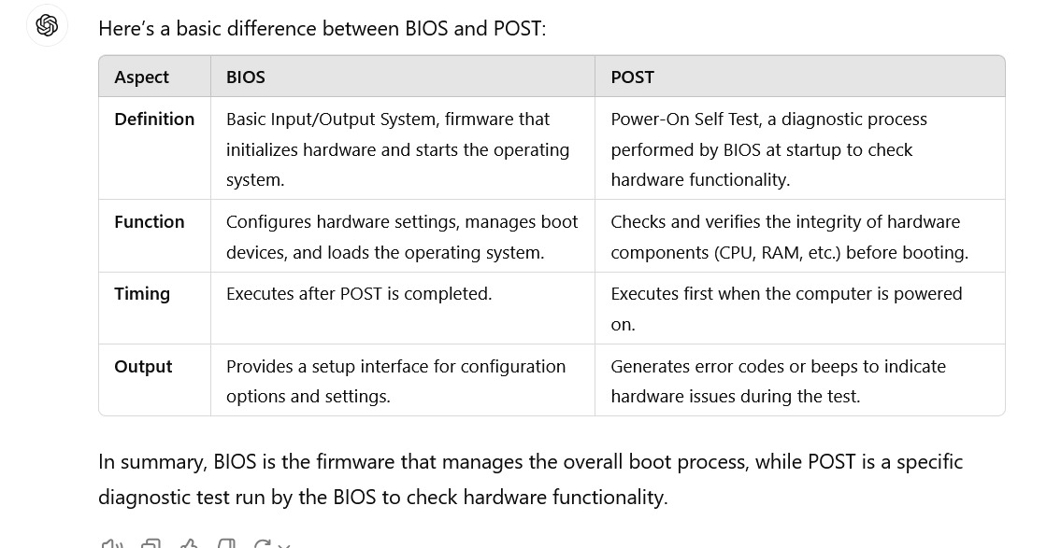

Types of SSD?
When selecting an SSD, consider factors such as speed, capacity, form factor, and intended use. NVMe and M.2 SSDs are generally preferred for high-performance applications, while SATA SSDs provide a cost-effective upgrade from traditional HDDs.
Tell me CPU parts.
- Arithmetic Logic Unit (ALU):
  - The ALU performs arithmetic operations (like addition, subtraction, multiplication, and division) and logical operations (like AND, OR, NOT, and XOR).
  - It is responsible for executing instructions that involve calculations and data manipulation.
- Control Unit (CU):
  - The CU manages the flow of data and instructions between the CPU and other components, such as memory and input/output devices.
  - It fetches instructions from memory, decodes them, and directs the appropriate CPU components to execute them.
- Registers:
  - Registers are small, high-speed memory locations within the CPU used to temporarily store data, instructions, and addresses.
  - Common types of registers include:
    - Program Counter (PC): Stores the address of the next instruction to be executed.
    - Instruction Register (IR): Holds the current instruction being executed.
    - Accumulator (AC): Used for arithmetic and logical operations.
    - General-Purpose Registers: Used for various purposes, such as storing operands and results.
    - Status Register (SR): Contains flags that indicate the result of operations (e.g., zero, carry, overflow).
- Cache:
  - CPU cache is a high-speed memory used to temporarily store frequently accessed data and instructions to reduce the time it takes to access them from the main memory (RAM).

  - Modern CPUs have multiple levels of cache, typically L1, L2, and L3, with L1 being the fastest and closest to the CPU core.
- Bus Interface:
  - The bus interface connects the CPU to the system bus, which is a shared communication channel that allows different components (like memory, storage, and peripherals) to exchange data with the CPU.
  - It consists of the address bus (for sending memory addresses), data bus (for sending and receiving data), and control bus (for sending control signals).
- Clock:
  - The CPU clock generates a periodic signal that synchronizes the actions of the CPU and other components.
  - The clock speed determines how many instructions the CPU can execute per second, measured in hertz (Hz).
- Cores:
  - Modern CPUs have multiple cores, which are essentially individual processors contained within a single chip.
  - Each core has its own ALU, CU, registers, and cache, allowing it to execute instructions independently and simultaneously with other cores.
- Floating-Point Unit (FPU):
  - The FPU is a specialized component designed to perform operations on floating-point numbers (numbers with decimal points).
  - It is used to accelerate mathematical calculations, such as those involved in graphics processing and scientific simulations.
- Memory Management Unit (MMU):
  - The MMU handles memory access and manages virtual memory, translating virtual addresses used by the CPU into physical addresses in RAM.
  - It also handles memory protection and caching.
These components work together to fetch, decode, and execute instructions, performing the calculations and data manipulations required to run software applications and operating systems. The design and efficiency of these components greatly impact the overall performance of a computer

Difference between RAM and ROM. Why RAM is Called Random Access Memory?
RAM ALLOWS FOR BOTH READ AND WRITE OPERATIONS. BUT ROM READ OPERATIONS ALLOWED.
DATA IN RAM CAN BE READ OR WRITE IN ANY ORDER IT ALLOWS THE CPU TO ACCESS ANY MEMORYT CELL DIRECTLY WITHOUT READING THROUGH OTHER DATA SEQUENTIALLY.
Difference between Kernel Level and User Level thread?
User-Level Threads (ULTs):
Ult: threads are created and maintained by user library.
One thread is blocked entire process is blocked . content switching faster bcz no kernel is involvement. Ex: temple run while playing I would swipe or tap. Iam playing a game inorder not to get bored at that iam using user level thread to keep engage like giving some rewards to the user and allowing to change the character allowing the game to pause or exit . this activity will affect process because there’s no kernel involvement .
Updating the character’s position.
Rendering the game graphics.
Detecting player input (e.g., swipes or taps).
Updating the score and game state.
All these threads are managed entirely by the game, without involving the operating system's kernel.
If one thread is stuck, the entire process can get stuck because the OS can’t schedule other threads of the game independently.
If one thread encounters a blocking operation, such as a file read or a long calculation, the whole game could pause.

Faster Switching: Switching between threads in user space is faster since there’s no kernel involvement.
Single Block Affects All: If one thread encounters a blocking operation, the entire process can block because the OS treats the process as a whole.
Less Overhead: The process manages threads on its own, reducing overhead since there’s no need for system calls to the kernel for thread operations.

Kernel-Level Threads (KLTs):
Kernel-Level Threads (KLTs) - Example: Web Server (Apache)

In a web server like Apache, the situation is more complex, as multiple user requests (e.g., visiting a webpage) are being processed simultaneously.

OS-Managed Multitasking: Each request, such as loading a webpage, is handled by its own thread. Unlike ULTs, these threads are managed by the operating system kernel, not the application itself. The kernel can schedule these threads across multiple CPU cores and handle them independently.

Handling Blocking Calls: When a thread needs to perform a blocking operation (e.g., waiting for a response from a database), the kernel knows to stop that thread temporarily but allows other threads to keep running. For instance:
Thread A is waiting for data from a database (blocking).
Thread B is still able to load and serve a different webpage without being affected by Thread A’s wait.
• The kernel ensures all these threads get scheduled on different CPU cores (in a multi-core processor) or time-shared on a single core.
• If one thread (e.g., network) is waiting for data, the kernel allows other threads (like UI or rendering) to continue working.
• It performs context switching between threads efficiently, ensuring each thread gets CPU time and resources based on priority.
Kernel-Level Threads (KLTs) - Example: Web Server (Apache)

In a web server like Apache, the situation is more complex, as multiple user requests (e.g., visiting a webpage) are being processed simultaneously.

OS-Managed Multitasking: Each request, such as loading a webpage, is handled by its own thread. Unlike ULTs, these threads are managed by the operating system kernel, not the application itself. The kernel can schedule these threads across multiple CPU cores and handle them independently.

Handling Blocking Calls: When a thread needs to perform a blocking operation (e.g., waiting for a response from a database), the kernel knows to stop that thread temporarily but allows other threads to keep running. For instance:
Thread A is waiting for data from a database (blocking).
Thread B is still able to load and serve a different webpage without being affected by Thread A’s wait.

Concurrency and Performance: The OS allocates resources efficiently. For example, if you have a multi-core processor, the OS can run multiple threads in parallel across cores. Even if some threads are blocked, other threads continue running, maximizing system performance.
Concurrency and Performance: The OS allocates resources efficiently. For example, if you have a multi-core processor, the OS can run multiple threads in parallel across cores. Even if some threads are blocked, other threads continue running, maximizing system performance.
Concurrency and Parallelism: Threads are managed independently by the kernel, allowing true parallelism on multi-core systems.
Non-blocking Execution: A blocking call on one thread doesn’t affect others, as the kernel can continue executing other threads.
Increased Overhead: Context switching between kernel threads is slower than ULTs because it involves the kernel and system calls.

Summary:

ULTs (Temple Run Example): The game manages threads without involving the OS. It's fast but limited in handling blocking operations.
KLTs (Apache Web Server Example): The operating system manages threads. It’s slightly slower due to kernel involvement, but offers better concurrency, especially when tasks (like web requests) are blocking.

Kernel Mode
- What It Is:
Kernel mode is a privileged mode where the code has full access to all system resources, including hardware and memory. The operating system kernel runs in this mode, and it can execute any CPU instruction and access any memory address.
- Purpose:
The kernel is responsible for managing system hardware, executing low-level tasks, and providing services to applications. Kernel mode allows the operating system to interact directly with hardware and manage system resources like memory, CPU scheduling, and I/O devices.
- Examples of Kernel Mode Operations:
  - Accessing hardware devices (e.g., reading from a disk, sending data over a network)
  - Managing memory (e.g., allocating memory to programs)
  - Handling system calls from applications (e.g., opening files, managing processes)
  - Interrupt handling (e.g., responding to hardware interrupts from devices like keyboards or network cards)
- Risks:
Since kernel mode has unrestricted access, any error or bug in the code running in this mode can crash the entire system, cause data corruption, or introduce security vulnerabilities.
- Who Runs in Kernel Mode:
  - The operating system kernel
  - Low-level system drivers
  - Some system-level services that require direct access to hardware

2. User Mode
- What It Is:
User mode is a restricted mode where most of the application code runs. In user mode, the code has limited access to system resources and must interact with the operating system to access hardware or perform privileged operations.
- Purpose:
The primary purpose of user mode is to protect the operating system and other applications from malicious or buggy software. User-mode programs cannot directly access hardware or memory managed by the kernel. If a program in user mode needs access to these resources, it must request the kernel's help through system calls.
- Examples of User Mode Operations:
  - Running applications like web browsers, word processors, and games
  - Executing user-level processes (e.g., running a Python script)
  - Handling non-privileged tasks (e.g., rendering a webpage, calculating numbers)
Blue Screen of Death (BSOD) in Windows), as the kernel has unrestricted access to system resources.
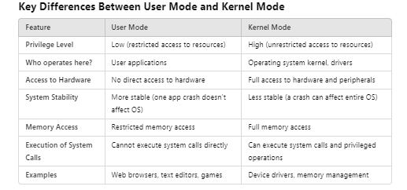

User mode have restriction to access system resources.
Example: A web browser runs in user mode. It can render web pages but cannot directly access the network or files.
Kernel mode have no restriction to access system resources.
Example: The operating system kernel handles a network request on behalf of the browser using system calls (e.g., send()).

Why User Mode and Kernel Mode are Important:
- Security: User-mode programs are isolated from each other and from critical system resources, reducing the risk of one faulty or malicious program causing system-wide problems.
- Stability: User mode ensures that if an application crashes, it won’t crash the entire system. The kernel handles critical tasks and keeps the system stable.
- • User mode is used for running applications with restricted access to system resources, ensuring stability and security.
- • Kernel mode is used by the operating system to manage hardware and execute critical system tasks with full access to system resources.
Yes, a switch from user mode to kernel mode can happen, but you (the user or a user-mode application) cannot directly control this switch. The switch occurs through a controlled mechanism, typically via system calls.
How the Switch Happens:
- System Call:
  - What is it?
A system call is a request made by a user-mode application to the operating system (which runs in kernel mode) to perform an action that requires higher privileges (e.g., accessing hardware or managing memory).
  - Example:
When a program wants to open a file, it can’t do it directly. It makes a system call (like open(), read(), or write() in Linux/Unix) to the operating system. The OS then handles the request in kernel mode and returns the result to the program.
- Interrupts and Exceptions:
  - Interrupts: When hardware needs immediate attention (like a keystroke or a mouse click), an interrupt is sent to the processor. The CPU switches to kernel mode to handle this interrupt.
  - Exceptions: Errors such as division by zero or invalid memory access can trigger exceptions. The system switches to kernel mode to handle these errors.
- Context Switching:
  - During multitasking, the kernel manages which process runs at any given time. When the OS scheduler switches between processes, this involves switching between user mode and kernel mode.
Example of a User Mode to Kernel Mode Switch:
- Opening a File in a Program:
  - You’re using a text editor (running in user mode) and decide to open a file.
  - The program makes a system call (e.g., open() in C) to the operating system.
  - The CPU switches to kernel mode to execute the system call.
  - The OS reads the file from the disk (accessing the hardware), switches back to user mode, and returns the data to your text editor.
Why Can’t You Directly Switch?
- Security and Stability: Allowing a user-mode program to switch directly to kernel mode could lead to serious security vulnerabilities. Any application could access and modify critical system components, potentially crashing the system or introducing malware.
- The operating system controls the transition to prevent unauthorized access and ensure stability.
Switching from Kernel Mode Back to User Mode:
Once the kernel completes the requested task, it switches back to user mode, returning control to the user-mode program. This process is carefully managed by the OS to ensure that the kernel only runs for the duration of the necessary privileged operation.
Steps in a User-Mode to Kernel-Mode Switch (System Call Example):
- User Program issues a system call (e.g., open()).
- CPU switches to kernel mode to allow the OS to handle the request.
- The kernel processes the request (accessing hardware or system resources).
- The CPU switches back to user mode after completing the request.
- Control is returned to the user program with the result (e.g., file opened successfully).
You as a user or application developer cannot directly switch from user mode to kernel mode.
The switch occurs through system calls or interrupts, which are controlled mechanisms provided by the operating system.
Given Page Size, No of bits in Logical and Physical Address space. Find the total no of pages and frames?
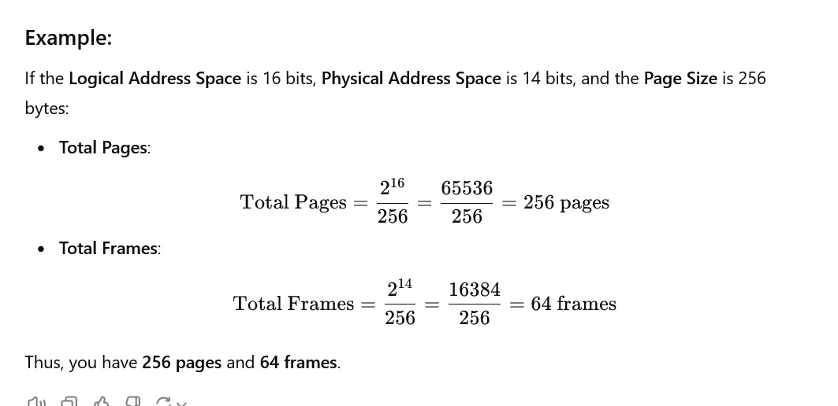





what is physical and logical address
ChatGPT said:
ChatGPT
In computer systems, physical addresses and logical addresses refer to two different types of addressing used in memory management. Understanding the distinction between these two types of addresses is crucial for grasping how memory management works in modern operating systems.
1. Logical Address
- Definition: A logical address (also known as a virtual address) is the address generated by the CPU during a program's execution. It is the address that a program uses to access memory locations.
- Characteristics:
  - Generated by the CPU: When a program is running, it uses logical addresses to refer to memory.
  - Not directly usable by the hardware: Logical addresses do not correspond to actual physical locations in memory. They must be translated to physical addresses by the memory management unit (MMU) of the CPU.
  - Used in virtual memory systems: Logical addresses allow operating systems to implement features like virtual memory, enabling multiple programs to run simultaneously without interfering with each other.
- Example: If a program requests memory for an array of integers, the addresses used within the program to access this array are logical addresses.
2. Physical Address
- Definition: A physical address is the actual location in the computer’s main memory (RAM) where data is stored. This is the address that the memory hardware uses to access data.
- Characteristics:
  - Directly used by the memory hardware: Physical addresses refer to actual locations in memory and are used by the hardware to read from or write to memory.
  - Result of translation: Physical addresses are derived from logical addresses through a process called address translation.
  - Specific to the hardware: Each physical address is unique and corresponds to a specific byte in physical memory.
- Example: When data is stored in RAM, it resides at a physical address (like 0x1A3B) that the memory controller uses to retrieve or store data.
Address Translation
To access a particular memory location, the logical address must be converted into a physical address. This is usually handled by the Memory Management Unit (MMU) using a mapping technique such as:
- Paging: Divides logical memory into blocks of physical memory, allowing non-contiguous allocation.
- Segmentation: Divides memory into segments of varying lengths based on logical divisions (like functions or arrays).
Real-World Analogy
- Logical Address: Think of it as an apartment number in a building. It tells you where to go within the building but does not specify the building’s actual street address.
- Physical Address: This is the actual street address of the building. It tells the postal service where to deliver the mail.
Conclusion
- Logical addresses are used by programs and represent locations in virtual memory, while physical addresses correspond to actual locations in RAM.
- The operating system and the MMU handle the translation between these two types of addresses, allowing for features like virtual memory and process isolation.
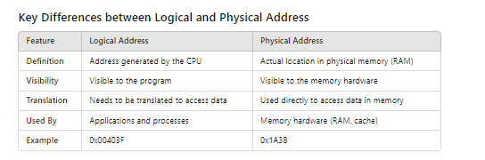

What is a System Call? Why it is required?
ChatGPT said:
ChatGPT
A system call is a way for a program (typically running in user mode) to request a service from the operating system's kernel (which runs in kernel mode). System calls provide an interface between user applications and the underlying hardware and operating system functionalities.
What is a System Call?
- Definition: A system call is a predefined interface that allows user-space applications to communicate with the operating system kernel. It acts as a bridge between the user program and the hardware resources.
- Mechanism: When a program requires an operating system service (e.g., file manipulation, process control, memory management), it triggers a system call to request that service. The CPU switches from user mode to kernel mode to execute the system call.
Types of System Calls
System calls can be categorized into several types, including:
- File Management:
  - Example: open(), read(), write(), close()
  - Purpose: To create, read, write, and close files.
- Process Control:
  - Example: fork(), exec(), wait(), exit()
  - Purpose: To create, manage, and terminate processes.
- Device Management:
  - Example: ioctl(), read(), write()
  - Purpose: To interact with hardware devices.
- Information Maintenance:
  - Example: getpid(), alarm(), sleep()
  - Purpose: To retrieve and manage system information.
- Communication:
  - Example: pipe(), shmget(), msgget()
  - Purpose: To enable communication between processes, either on the same machine or over a network.
Why System Calls Are Required
System calls are essential for several reasons:
- Controlled Access to Hardware:
  - User applications cannot directly access hardware resources for security and stability reasons. System calls provide a controlled way to access these resources through the operating system.
- Resource Management:
  - The operating system manages resources like CPU, memory, and I/O devices. System calls help applications request and release these resources effectively.
- Process Isolation:
  - By using system calls, the operating system ensures that processes are isolated from each other, preventing one process from interfering with another's memory or resources.
- Abstraction:
  - System calls abstract the complexities of hardware management. Developers can use higher-level programming constructs without needing to manage hardware directly.
- Error Handling:
  - System calls provide a standard way to report errors. When a system call fails, it can return an error code that applications can handle gracefully.
- Security:
  - The operating system can enforce security policies when processing system calls, such as checking permissions before granting access to sensitive resources.
Example of a System Call
For example, consider a user program that wants to read data from a file:
- User Program Request: The program calls the read() system call.
- Mode Switch: The CPU switches from user mode to kernel mode.
- Kernel Execution: The operating system checks the file descriptor, verifies permissions, and reads the requested data from disk into memory.
- Return to User Mode: The kernel returns control to the user program, providing the requested data.
Conclusion
- System calls are a crucial mechanism that enables user applications to interact with the operating system, providing controlled access to hardware resources and essential services.
- They allow for efficient resource management, process isolation, and security, making them a fundamental aspect of modern operating systems.
What is Memory Management Unit?
The MMU is sometimes housed in a separate Integrated Chip (IC), but it is typically found inside the central processing unit (CPU) of the computer. The MMU receives all inputs for data requests and decides whether to retrieve the data from ROM or RAM storage.
Explain one level paging with a diagram?
ChatGPT said:
ChatGPT
One-level paging is a memory management technique that divides the logical address space of a process into fixed-size pages and the physical memory into fixed-size frames. The purpose of this is to allow non-contiguous allocation of memory, making memory management more efficient and preventing fragmentation.
Key Concepts of One-Level Paging:
- Pages: The logical address space (virtual memory) is divided into fixed-size units called pages.
- Frames: The physical memory (RAM) is divided into fixed-size units called frames, which are of the same size as the pages.
- Page Table: The operating system maintains a page table for each process that maps the page numbers (in logical address space) to frame numbers (in physical memory).
Components of One-Level Paging
- Logical Address (Virtual Address): Consists of two parts:
  - Page number (p): Identifies the page in the logical address space.
  - Offset (d): Identifies the specific location within the page.
- Physical Address: The physical address where the data is actually stored, obtained by combining the frame number and the offset.
Address Translation Process
The MMU (Memory Management Unit) translates the logical address to a physical address using the page table.
- Extract Page Number and Offset from the logical address.
- Look up the Page Table using the page number to find the corresponding frame number.
- Combine Frame Number and Offset to get the physical address.
Diagram of One-Level Paging
sql
Copy code
Logical Address Space (Virtual Memory)
+--------------------------------------+
| Page Number | Offset |
| (p) | (d) |
+-------------+------------------------+
|
v
+--------------------------------------+
| Page Table |
+--------------------------------------+
| Page No | Frame No |
| 0 | 5 |
| 1 | 2 |
| 2 | 8 |
| 3 | 1 |
| ... | ... |
+--------------------------------------+
|
v
Physical Memory
+--------------------------------------+
| Frame 0 | Frame 1 | Frame 2 |
| | Data | Data |
+--------------------------------------+
Example:
- Logical Address: Suppose the CPU generates a logical address 0x1234. This can be broken into:
  - Page number = 0x1
  - Offset = 0x234
- Page Table Lookup: From the page table, we see that page 1 is mapped to frame 2.
- Physical Address: The physical address is constructed by combining the frame number (2) with the offset (0x234), giving a physical address in frame 2.
Advantages of One-Level Paging:
- Eliminates external fragmentation: Since memory is allocated in fixed-size pages and frames.
- Efficient memory utilization: Pages can be loaded into any available frame, allowing better use of physical memory.
Conclusion:
One-level paging simplifies memory management by dividing the logical address space into pages and mapping them to physical memory frames. The page table keeps track of the mapping, allowing processes to run in non-contiguous memory locations without the program being aware. This system reduces fragmentation and maximizes the utilization of memory.
Can cache memory be upgraded?
Cache memory is built into the CPU or located very close to it, so it cannot be upgraded separately like RAM. To get more or faster cache, you would need to upgrade the entire CPU
How does cache memory work?
Cache memory works by storing copies of frequently accessed data from the main memory. When the CPU needs data, it first checks the cache. If the data is found (a “cache hit”), it is quickly accessed. If not (a “cache miss”), the data is fetched from the slower main memory.

The terms concurrency and parallelism are often used in computing, and while they are related, they refer to different concepts in how tasks are executed.
Key Difference:
- Concurrency: Refers to the ability of a system to handle multiple tasks at the same time, but not necessarily executing them simultaneously. It involves switching between tasks so that multiple tasks are in progress but may not be executed exactly at the same moment.
- Parallelism: Refers to the simultaneous execution of multiple tasks at the same time, on multiple processors or cores. Tasks are literally running in parallel.
Concurrency in Practice:
- Concurrency is about dealing with lots of things at once.
- Example: A single-core CPU running multiple applications by switching between them quickly. The applications are in progress concurrently but not executing at the same time.
Parallelism in Practice:
- Parallelism is about doing multiple things at once.
- Example: A multi-core CPU executing multiple processes simultaneously, where each process is running on a different core.

Analogy:
- Concurrency is like a single person (CPU) working on multiple tasks by switching between them, giving attention to one task at a time but making progress on all.
- Parallelism is like multiple people (CPU cores) working on different tasks simultaneously, where each task is being worked on at the exact same time.

Conclusion:
- Concurrency enables a system to handle multiple tasks by switching between them, while parallelism requires actual simultaneous execution on multiple cores or processors.
- A system can be concurrent without being parallel, but a parallel system typically involves concurrency as well.
